**CHAT SPHERE**

JANVI NIMISH SURI

*Department of Computer Science and Engineering, Department of Computer Science and Engineering*

*APEX INSTITUTE OF TECHNOLOGY APEX INSTITUTE OF TECHNOLOGY*

*Chandigarh University Chandigarh University*

Gharuan, Mohali-140413, PUNJAB Gharuan, Mohali-140413, PUNJAB

20BCS4537@cuchd.in 20BCS4550@cuchd.in

GAURAV MALIK SACHIN CHAUDHARY

*Department of Computer Science and Engineering, Department of Computer Science and Engineering*

*APEX INSTITUTE OF TECHNOLOGY APEX INSTITUTE OF TECHNOLOGY*

*Chandigarh University Chandigarh University*

Gharuan, Mohali-140413, PUNJAB Gharuan, Mohali-140413, PUNJAB

20BCS4573@cuchd.in 20BCS4517@cuchd.in

***Abstract*—*The emergence of new technologies has led to major changes in personal communication. Today, one of the popular communication methods of the digital age is the use of text messages. Various types of communication have been developed to meet communication needs. This article presents an interactive application developed using the MERN framework, a general engineering framework for developing web applications. The app allows users to instantly create accounts and exchange messages and information. It also includes user authentication and authorization features to provide secure access to interactive features. Through this work, we demonstrate the feasibility and effectiveness of using the MERN cluster to build a live chat application.***

***The live chat application discussed in this article provides features such as instant messaging, interactive sharing, and user visibility to create an engaging, beautiful, and interactive experience. Users can have one-on-one or group discussions, encouraging effective collaboration in a personal and professional environment.***

***The chat app is designed to allow messages to be sent and received almost instantly, prioritizing low latency. This is done using WebSocket technology, which enables two-way communication between the client and the server. Backend infrastructure leverages scalable and powerful database to manage user profiles, message history and other data.* *This article describes the communication process of real-time chat applications and explores the use of WebSocket technology for two-way communication between client and server. Server-side technologies such as Node.js and Express are used to create a responsive and scalable backend, while the front-end leverages modern frameworks such as React.js to provide a dynamic and interactive user interface.***

***Keywords*—*MERN stack, Two-factor authentication, WebRTC, Socket, Real-time, Malware.***

I. Introduction

With the passage of time and the rapid advancement of information and communication technology, it has become an important part of society. This technology allows people

to easily access information and communicate with unprecedented speed from anywhere. In today's conditions, many people are abandoning traditional sources such as newspapers and television news and using smart devices such as smartphones to obtain more information. At the center of this change is the important role played by social practices; people use these platforms to exchange information and discuss current events locally and globally. However, it should be acknowledged that these communication applications have their own advantages and disadvantages that affect technology in general.

User feedback and personal experiences with these apps help people evaluate key features and identify areas for improvement. It is important to emphasize that the contact application has been carefully designed to be fully responsive, user-friendly and accessible from a variety of devices, including web and mobile platforms. This application support system includes MongoDB as well as HTML, CSS, JavaScript libraries, and WEB-rtc, all of which come together to keep applications running smoothly.

In this research work, a real-time chat app is introduced for users to chat easily and securely. Section 2. In this section a literature review is conducted to understand the technologies and models used in the system. Section 3. In this section working methodology and various technologies and models used in our project is explained. Section 4. This section includes the final output of our research, it includes the screenshots of the final system. Section 5. Finally concluding remarks and future directions are given in the section.

II. Literature Review

The history of instant messaging apps traces the fascinating way they have changed the way people communicate and share information in the digital age. This journey began in 1988 with the introduction of Internet Relay Chat (IRC), which was a major milestone in the development of live chat. IRC lays the foundation for the next evolution of instant messaging by allowing users to connect to servers and have real-time text conversations in chat rooms.

The late 1990s and early 2000s witnessed the rise of instant messaging with the emergence of new platforms such as AOL Instant Messenger (AIM), ICQ (Looking For You), MSN Messenger, and Yahoo Messenger. Launched by America Online (AOL) in 1997, AIM quickly gained popularity by introducing the concept of "friend lists" that allowed users to monitor their contacts' online status and instant messaging, thus improving communication and user experience. . Live chat friends.

Introduced in 1996, ICQ introduced the concept of user-specific and user-friendly connections. Microsoft's MSN Messenger and Yahoo Messenger continue to evolve the instant messaging space by offering chat capabilities with additional features such as file sharing.

With the rise of smartphones and the popularity of mobile messaging, live chat continues to evolve. Platforms such as WhatsApp (2009), Facebook Messenger (2011) and WeChat (2011) have extended instant communication to mobile devices, making communication more powerful and flexible by offering not only messaging but also features such as sending multiple messages and sharing photos and videos.

As live chat applications evolved, they incorporated advanced features such as voice and video calling, group chats and task automation bots. To address security and privacy concerns, end-to-end encryption has been developed to protect user data. Live chat applications have evolved into a variety of tools that are now integrated into many services, from payment to e-commerce to gaming platforms, making them a tool for communication and conversation. This historical journey demonstrates a remarkable transition from text-based meeting rooms to advanced multimedia communication systems and highlights the importance of these systems under digital communication in this dynamic environment.

A. Key Features and Functionalities

The all-in-one live chat platform includes essential features designed to enhance communication and collaboration. The main feature of these applications is instant messaging, which allows users to participate in real-time conversations. In addition to text, users can also share multimedia content such as photos, videos and documents without any problems. The group chat feature encourages conversation, while the addition of emoticon stickers improves empathy. The platform keeps messages private with strong security measures, including advanced encryption.

Users receive quick notifications of incoming messages and it is easy to find contacts and communicate with friends and colleagues. Additionally, users can create backups of their chat history for convenience. The user interface is designed to be user-friendly and intuitive, allowing for effortless navigation. Users can personalize their conversations through slight text customization, and customizable themes enable adjustments to the app's appearance based on preferences. Effective search functions aid in the rapid retrieval of specific information from chat histories.

The platform's integration with additional applications and services, along with the presence of automated bots, enhances its overall utility. Whether used for personal or professional purposes, the versatility and cross-platform compatibility of these chat applications establish them as invaluable tools for modern communication and collaboration.

B. User behavior and trends

Understanding how users use live chat and related topics is key to uncovering the differences between these platforms [2]. Research in this area offers many perspectives on how people interact with digital media by exploring communication patterns such as frequency, nature of interaction, interactive integration of multimedia, and time response power. It also explores users' preferences for specific communication applications and their consistent shifts across communication devices.

Furthermore, analysis of adoption patterns shows an impact on users' initial choice and continued use of dating apps. Examines the impact of recommendations, social interactions, and key features during early adoption. Similarly, the study focuses on user retention to identify factors that influence customer loyalty, such as satisfaction, ease of use and all-electric use. Conversely, inquiries into switching patterns and attrition seek to uncover reasons for users migrating to alternative applications or discontinuing use, which may be related to security concerns, changing functionalities, or the emergence of competing platforms.

The demographic dimension adds depth to the analytical perspective, with researchers exploring whether variables like age, gender, geographical location, and cultural context influence user behavior and adoption tendencies [9]. In summary, a comprehensive understanding of user behavior and adoption trends in real-time chat applications is invaluable for both app developers and researchers. It empowers them to improve user experiences and anticipate evolving user needs in the ever-changing landscape of digital communication.

C. Privacy and Security Considerations

Ensuring privacy and security is the most important issue in instant messaging applications. This is particularly important due to the confidentiality of information transmitted through these platforms. Addressing these features is important for establishing and maintaining user trust, protecting user data, and promoting secure communications. This discussion will highlight the importance of privacy and security within the application process.

The main purpose in the field of live chat is to protect user data and communication [4]. Data privacy, which includes the protection of personal information, communications and media, is of paramount importance. To reduce the threat of unauthorized access, these applications often use encryption methods such as end-to-end encryption. This method ensures that only the intended recipient can decrypt and access messages, making messages unintelligible to potential listeners. Privacy-conscious users tend to prefer dating apps that prioritize the privacy of their personal information, so look for reassurance in privacy features.

The integrity of the messaging platform depends on many aspects of user authentication and access control. These features authenticate the user and prevent unauthorized access. Most often this involves the use of various authentication methods as well as usernames and passwords. Most users can also decide who can initiate chats with them and view their information. Access control allows users to customize their own privacy settings and trust the security of the application.

It is very important to maintain a safe and respectful environment for live chat applications. These platforms are open to abuse, which may include sharing inappropriate or problematic content [11]. To solve this problem, social media providers often use content filtering and advertising techniques. Users can report content deemed inappropriate or abusive, allowing administrators to take swift action. This may include issuing notices, suspending deposits, or imposing restrictions. These measures not only protect users, but also help provide a safer and better user experience.

Security is an ongoing issue in real-time chat applications. It is crucial for developers to stay vigilant and take a proactive approach to detect and resolve security vulnerabilities. Keeping the application up-to-date with regular updates and patches is necessary to strengthen its defenses against new threats. Swift responses to vulnerabilities play a key role in preventing data breaches and unauthorized access, ultimately maintaining users' trust and confidence in the security of the application.

D. Problem statement

This project aims to develop a chat application featuring a server that facilitates real-time communication among users. The goal is to create an intuitive and user-friendly instant messaging solution, ensuring accessibility for users of all levels of expertise. The subsequent section outlines the development strategy for this web application:

The development process for our chat application centered on establishing a platform for real-time user communication, utilizing the MERN stack—a prevalent and contemporary technology stack within the industry. The application's frontend was crafted using React, while the backend employed Node.js and Express.js, with data storage managed through MongoDB.

During the initial phase, our focus was on configuring the development environment, installing essential tools and libraries, creating a project skeleton [12], and defining the fundamental structure of our application. This phase played a pivotal role in laying a robust foundation for our development endeavors.

Moving into the second phase, we formulated the database schema, developed requisite models and controllers, and implemented user authentication, authorization, and RESTful APIs to handle data retrieval and manipulation. This step was crucial for ensuring the security and protection of user data.

The third phase involved constructing the frontend user interface using React, incorporating various UI libraries and frameworks like Material-UI and Bootstrap to achieve an appealing and responsive design. Additionally, we implemented client-side routing and seamlessly integrated with backend APIs.

In the concluding phase, extensive testing and debugging were undertaken to guarantee the application's error-free performance and optimal functionality. Subsequently, the application was deployed to a cloud platform, such as AWS or Heroku, to enhance user accessibility.

In summary, our chat application built on the MERN stack offers users an efficient and smooth means of real-time communication, underlining our commitment to delivering a seamless user experience.

E. Proposed system

After logging into the chat application, users are required to provide login information. If they do not have an account, they must first register. Both the login and registration pages offer the option to sign up using a Google or Facebook account.

After successfully logging in, the user must specify the room name to start the conversation. If the user does not have a room name, they can create one and invite their friends to join a particular room. After entering the room name, the user will be directed to the chat page.

There are two sections in the left sidebar of the chat application. One displays the room name the user has joined, while the other shows the currently online users in that chat room. Additionally, users can explore the option to join other rooms and log out as needed.

F. Modules of real time chat app

User Authentication Component: This component is responsible for managing user credentials and logging in via Firebase Authentication. It helps to create user accounts, log in and log out of the application using email and password. It also monitors the user's session management, providing continuous access until the user obviously leaves or the session expires.

Chat Room Function: This function is specially designed to create and manage a chat room. Users can create new chat rooms, join existing chat rooms, and view the list of existing chat rooms. Privacy settings, including password protection and invitation-only access, are also managed through this device.

Instant Messaging: This feature supports sending and receiving instant messages using the Firebase Realtime database. Users can transfer text, images and other files. This tool also checks word formatting and supports features like bold, italics, and underline.

User Blocking: This feature prevents users from sending messages to others. Users can easily block and remove others, ensuring that blocked users cannot send messages to the user who initiated the block.

Notification System: This system manages notifications of new messages and provides various notification settings such as sound and vibration notifications. It is also responsible for displaying reports on different devices and platforms.

User Profile Management: This function manages the creation and management of user profiles. Users can create a profile using their name, profile picture and other details. This module also controls the presentation of user profiles in the switchboard.

Admin Panel Function: This function is responsible for the management of the chat application. It provides an admin panel that allows administrators to manage users, chat rooms, and messages. With functions like banning a user and deleting the chat room.

Compatibility design: This tool makes the design of the application interactive, allowing the user interface to adapt to different sizes and devices. This ensures a seamless user experience across multiple platforms.

Multilingual support: This feature handles multilingual support for chat by providing multiple language options for the user interface. Users can easily choose their favorite language.

G. Applications

Live chat applications have become versatile tools that are revolutionizing digital communication and collaboration. These apps allow users to exchange messages in real time, providing a great way for interaction. Although the live chat application seems simple, it has many features in sectors such as business, education, healthcare and entertainment.

Live chat applications that enable communication and collaboration in the business world and organizations are now indispensable. Platforms like Slack, Microsoft Teams, and Google Talk, along with other business software, have revolutionized collaboration by supporting not only text but also information sharing, video conferencing, and collaboration. This change increases productivity, improves communication, and improves team dynamics.

When it comes to customer support, online chat or dedicated services help companies provide fast service. This leads to rapid issue resolution, reduced response times, and enhanced customer satisfaction, offering a win-win situation for both businesses and their clients.

The education sector has also experienced a profound impact, with real-time chat applications becoming essential in online learning and virtual classrooms. Educators and students use these platforms for discussions, questions, and collaborative projects, fostering a sense of community and making education more interactive.

In healthcare, real-time chat applications play a crucial role in telemedicine, allowing healthcare providers to offer real-time medical advice, prescriptions, and remote consultations. This has proven especially valuable during the COVID-19 pandemic, ensuring prompt care and guidance without the need for physical office visits.

Social networking platforms leverage real-time chat to provide instant messaging services, enhancing user engagement by enabling dynamic communication through text, images, videos, and multimedia content.

The e-commerce industry utilizes real-time chat to enhance customer experiences, allowing online shoppers to engage in immediate conversations with customer support agents. This personalized and instant support positively impacts sales and customer retention.

Multiplayer online gaming has seen a transformation with real-time chat applications, enabling gamers to communicate, strategize, and share experiences in real-time. This has led to the formation of a vibrant gaming community with global connections and friendships.

Entertainment and streaming services use real-time chat to foster audience engagement during broadcasts or streaming events. Viewers can interact with presenters, ask questions and share ideas, creating a sense of community and increasing the popularity of live and online events.

Organizations and participants understand the value of live communication for sharing and sharing information during virtual meetings, live concerts or sporting events. These unique sessions allow participants to gain insight, interact with others and share their experiences.

Live chat applications also play an important role in emergency response, facilitating instant communication and information sharing between response teams and the public. It performs testing when there is a disaster or problem. In such cases, sharing important information quickly reveals the importance of live chat applications.

III. Methodology

To create an interactive application, the first step would be to create a database system that can store user content, chat information, and messages [8]. MongoDB is the preferred data-driven database due to its adaptability and user-friendly features. This architecture is built from many collections, each dedicated to storing a specific type of information.

After creating the database model, the next step is to create a server-side API that is responsible for processing requests from clients. Express.js is a flexible and versatile Node.js web application framework for building server-side APIs. Features like routing, middleware, and templates make it the best choice for building web applications and APIs. Choose AngularJS to create responsive and user-friendly interfaces on the client side. AngularJS is a JavaScript-based framework that simplifies web development by providing a structured framework for visualization. It allows developers to easily create user interfaces using reusable code and components. Real-time message updates (required for interactive applications) are supported by Socket.io, a JavaScript library designed for real-time web applications.

Socket.io facilitates two-way communication between server and client, enabling updates and notifications. Client authentication is crucial and is implemented using JSON Web Tokens (JWT), a security mechanism for sending data between parties.

Finally, submit the application of the cloud hosting service using Node .js. Node.js is built on the Chrome V8 JavaScript engine, allowing JavaScript code to be executed server-side and providing a powerful and effective solution for building server-side applications. [7] It provides a fast and scalable platform, making it well-suited for developing web applications that can handle high traffic.

In summary, developing a chat application necessitates a blend of technologies and frameworks, each serving a specific purpose. The selection of technologies depends on the specific requirements of the application, such as real-time message updates, user authentication, and scalability. MongoDB, Express.js, AngularJS, socket.io, JWT, and Node.js were chosen for this specific chat application, resulting in a resilient and feature-rich application that met project requirements.

The detailed explanation of the technologies used in the chat application is as follows:

HTML, CSS, and JavaScript are fundamental tools for web development, providing the structure, style, and dynamic functionality to create interactive websites.

MongoDB is a cross-platform document-oriented NoSQL database known for its flexibility and scalability. It stores data in JSON-like documents, making it developer-friendly and suitable for web and mobile applications.

Express is a web application framework for Node.js, offering a robust set of tools for building back-end web applications and APIs. Its features, including routing and middleware, simplify the handling of HTTP requests and responses.

React, based on a component-based architecture, allows developers to create reusable UI components for building efficient and complex applications.

Node.js is a JavaScript runtime environment for executing server-side code, providing a cross-platform and efficient solution for scalable web applications.

WebRTC facilitates real-time voice, text, and video communication among web browsers and devices. Its JavaScript-based APIs enable seamless peer-to-peer communication without the need for additional plugins.

Two-Factor Authentication (2FA) enhances security by requiring users to provide two different authentication factors. This method adds an additional layer of protection beyond single authentication by using passwords primary and secondary (such as security tokens or biometric scans).

IV. Result and Discussion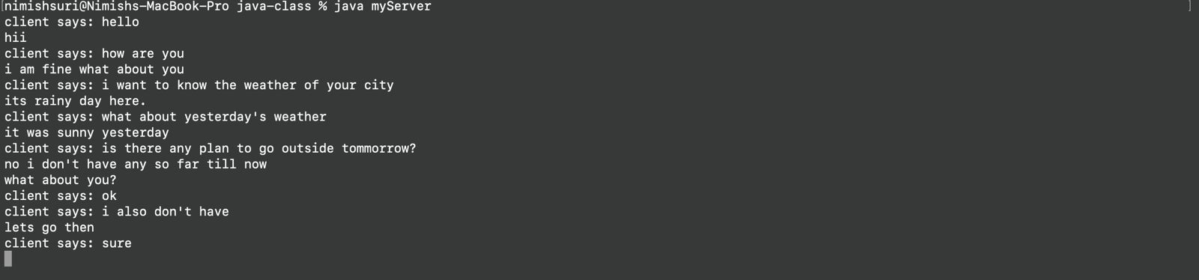

Fig.1 (Client side)

Live chat applications have become indispensable tools by offering many advantages in many fields and sectors. They improve business communication among team members and with external customers and partners in a professional environment. These applications help resolve customer support issues quickly, thus increasing customer satisfaction and often reducing support costs. In addition, live chat applications facilitate collaboration and work between colleagues, allowing instant conversations, collaboration and information sharing, making remote working more efficient.

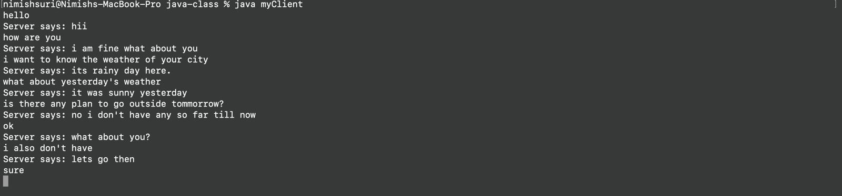

Fig.2 (Server side)

Live communication in education plays an important role, especially in the e-learning era. Schools are using this technology to facilitate online lessons, teacher-student interactions, and virtual classroom experiences, bridging geographic gaps and providing better access to education. The medical industry has also benefited from discussions around telemedicine and remote patient care. These applications enable instant communication between doctors and patients, providing consultation and effective care.

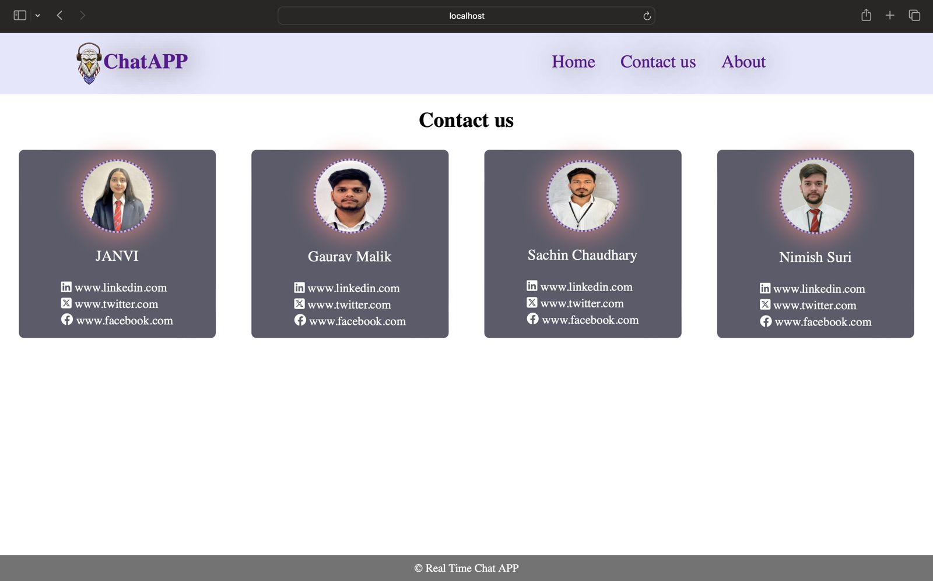

Fig.3 (Contact us)

The impact of real-time communication is also clearly seen in social media interaction. Popular social media platforms use live chat features to improve the quality of interactions by allowing users to instantly message their friends and contacts. In e-commerce, these applications are useful for resolving customer questions, tracking orders, and providing support. Live chat support helps improve the overall business by increasing sales by providing instant assistance during the purchasing process.

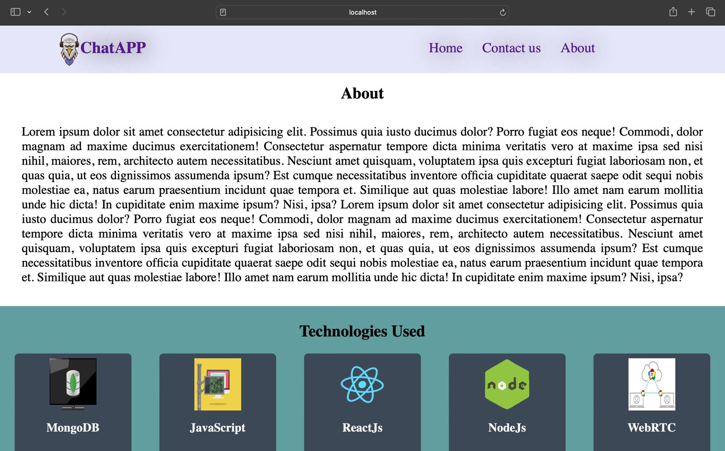

Fig.4 (About)

Live chat applications have revolutionized the entertainment and gaming industry. [5] Players can now communicate with other players, comment instantly and share their gaming experiences. This interaction fosters a beautiful gaming community that connects players around the world. Streaming services also use chat time to engage with viewers, providing the ability to interact, ask questions, and chat in real-time during broadcasts and online events.

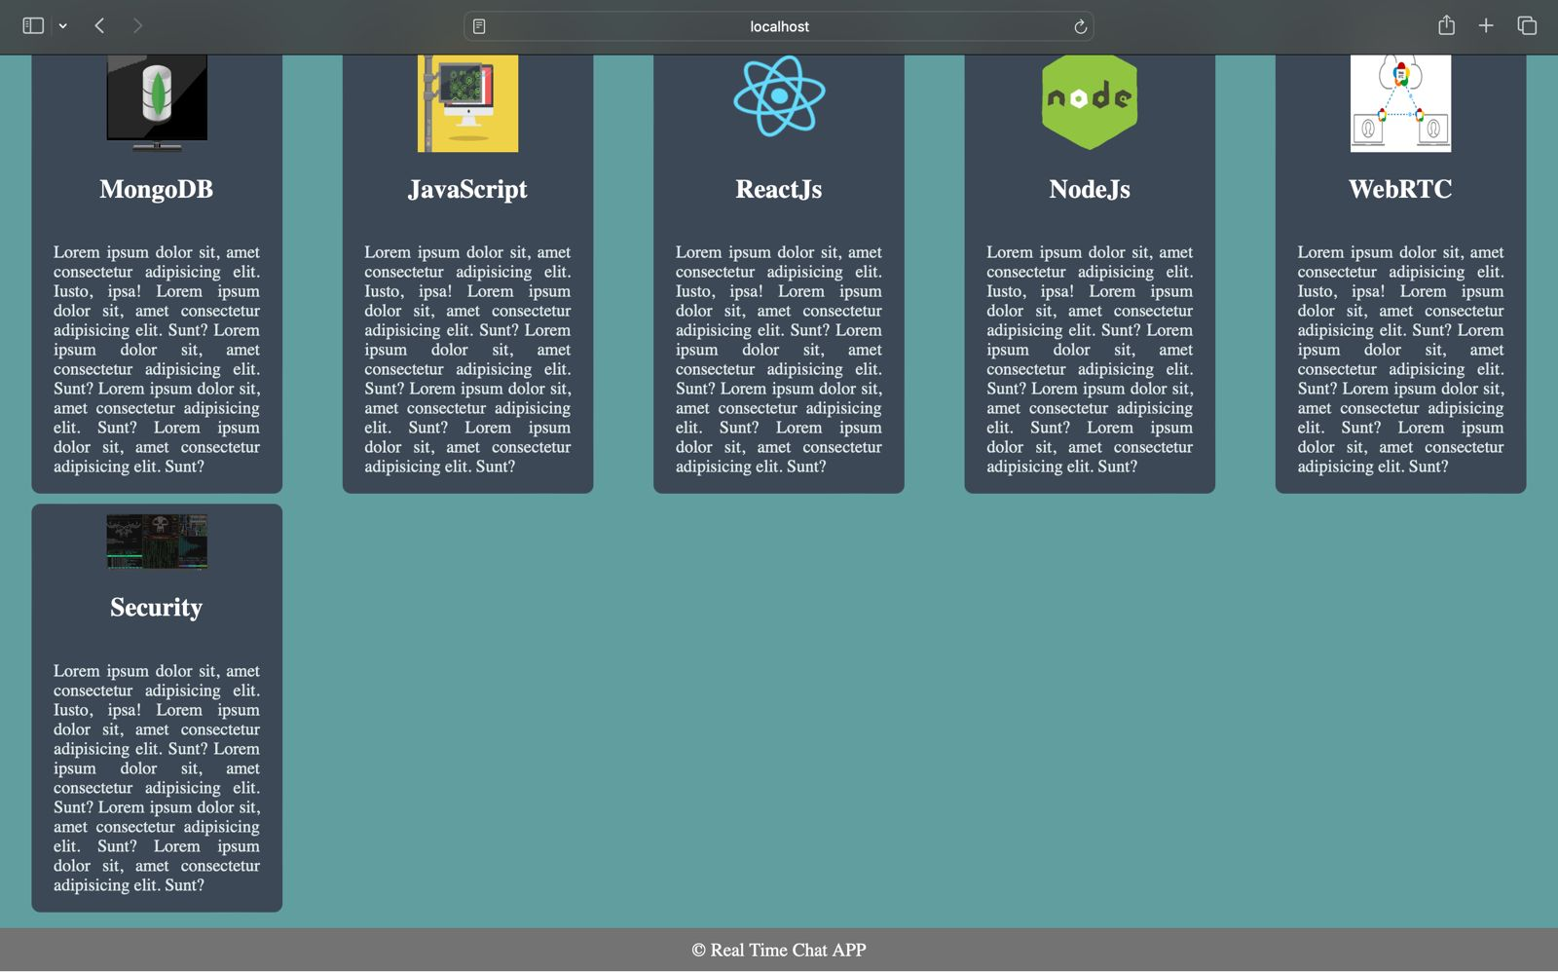

Fig.5(Technologies used)

Thanks to live chat applications, event management and collaboration become more efficient. Organizers and attendees can use these apps for instant updates, chats, and seamless collaboration during events, meetings, and conferences. Finally, live communication plays an important role in emergencies and disaster management. It facilitates collaboration, shares important information and provides assistance in critical situations, saving lives and enabling effective interventions.  
In summary, live chat applications have become versatile and revolutionary tools that improve communication and collaboration between countries. It helps improve efficiency, accessibility and user experience, reshaping the way people interact and connect in an ever-changing world.

V. CONCLUSION

As a result, building an interactive application using the MERN cluster turned out to be a challenging but rewarding task. Leveraging MongoDB, Express, React, and Node.js, we have created a powerful and flexible framework for building fast messaging and collaboration solutions that can be customized for different applications and businesses. The app prioritizes user experience, including features like new instant messaging and secure user authentication to ensure effective communication and protect the environment. The scalability and flexibility of the MERN cluster ensures good performance even at high user and message volumes.

Looking forward, there are many ways to develop and improve the application. These expectations include the integration of additional features such as video and voice chat, seamless integration with different applications and platforms, and better understanding and effective use of improved user interfaces. More importantly, the communication applications developed using the MERN group mark a significant achievement in the world of instant messaging and collaboration with the ability to change the way of communication and communicate online.

**REFERENCES-**

1. Masiello Eric. Mastering React Native. January 11, 2017. This book is a comprehensive guide to building mobile applications using React Native.
2. Naimul Islam Naim. ReactJS: An Open-Source JavaScript library for front-end development. Metropolia University of Applied Sciences. This article provides an overview of ReactJS and its key features for front-end web development.
3. Stefanov Stoyan, editor. React: Up and Running: Building web Applications. First Edition; 2016. This book is a beginner-friendly introduction to React, covering its core concepts and providing practical examples for building web applications.
4. Horton Adam, Vice Ryan. Mastering React; February 23; 2016. This book provides a comprehensive guide to React, covering its core concepts, practical examples, and advanced techniques for building complex applications.
5. Alex Kondov. Express Architecture Review. This article provides a review of the architecture of Express.js, a popular web framework for building Node.js applications.
6. Express.js documentation. This documentation provides a comprehensive guide to building web applications using Express.js.
7. Adam Horton. Node.js vs Python: What to Choose. This article provides a comparison of Node.js and Python for web development, highlighting their strengths and weaknesses.
8. Node.js documentation. This documentation provides a comprehensive guide to building server- side applications using Node.js.International Journal of Scientific Research in Science, Engineering and Technology | www.ijsrset.com | Vol 10 | Issue 2 Ms. Archana Nikose et al Int J Sci Res Sci Eng Technol, March-April-2023, 10 (2): 496-501 501
9. VSChart. This website provides a comparison of various programming languages and frameworks based on popularity, community support, and other factors.
10. MongoDB documentation. This documentation provides a comprehensive guide to using MongoDB, a popular NoSQL database for building web applications.
11. The paper by Lakshmi Prasanna Chitra and Ravikanth Satapathy aims to compare the performance of Node.js and traditional web servers, specifically Internet Information Services (IIS), in optimizing web application development. The authors conducted various tests to evaluate the performance of both platforms and determine which one is better for developing high-performance web applications.
12. React vs Angular: Key Differences. This article provides a comparison of React and Angular, two popular front-end frameworks for building web applications.
13. Al-Riyami, SS and K.G. Paterson, 2003. Uncertified public key cryptography. Methods for the Ninth World Theoretical Conference furthermore, Use of Cryptology and Information Security, November 30- Dec. 4, Springer Berlin Heidelberg, Taiwan, pages: 452-473. DOI: 10.1007/978-3-540-40061-5_29 Azab, A., P. Watters and R. Layton, 2012. [2]
14. Matches the Skype Network Traffic Forensics. 3 Internet Criminal Procedures and Trusted Computer Workshop, October 29-30, IEEE Xplore Press, Ballarat, pages: 19-27. Segment: 10.1109/CTC.2012.14 Bardis, N.G. furthermore, K. Ntaikos, 2008. [3]
15. Building security AES cryptographic-based visit application calculation and key administration. Methodology for tenth World WSEAS Conference on Mathematics Methods, Numeracy Methods and Intelligent Systems, (TIS '08), ACM, USA, pages: 486-49
16. Horton Adam. Vice Ryan, author. Mastering React; February 23; 2016. Accessed 1 Jan 2022
17. International Journal of Engineering Research & Technology Published by : ijert.org vol. 10 Issue 06, June-2021. Performance Optimization using MERN stack on Web Application.
18. Lakshmi Prasanna Chitra, Ravikanth Satapathy Department Of Computer Science Department Of Computer Science GITAM University Visakhapatnam, India Performance Comparison and Evaluation Of Node.Js And Traditional Web Server (IIS)
19. 2020 3rd International Conference on Computer and Informatics Engineering (IC2IE) 978-1-7281-8247-6/20/$31.00 ©2020 IEEE 261 Online Integration of SQL and No-SQL Databases using RestAPIs: A Case on 2 furniture e-Commerce Sites
20. Building a Real-Time Chat Application with React and Firebase" by Leigh Halliday
21. React Native Chat: Build a Chat App and Learn React Native and Firebase" by Konstantin Shkut.
22. PL/SQLBy Ivan Bayross.